**1. INTRODUCTION**

**Overview:**

This project aims to help poultry farmers identify diseases in chickens early using Artificial Intelligence (AI). Farmers in rural areas often struggle to recognize symptoms in time due to a lack of veterinary access and awareness. As a result, many chickens die from common but undiagnosed diseases, leading to financial loss and emotional stress.

To solve this, our team built a simple AI-powered web application. Farmers can upload a photo of their sick chicken, and the app will analyze the image using a pre-trained deep learning model (VGG16) to detect possible disease. The system then displays the disease name along with basic information and suggested actions.

**Key Features:**

* Image-based disease detection using Transfer Learning (VGG16)
* Simple and user-friendly web interface
* Disease name and prevention tips shown after prediction
* Potential for multi-language support (e.g., Telugu)
* Useful even in rural areas with minimal tech skills

**1.1 Ideation Phase**

**Define the Problem Statements**

|  |  |
| --- | --- |
| Date | 16th June 2025 |
| Team ID | LTVIP2025TMID34447 |
| Project Name | Transfer Learning-Based Classification of Poultry Diseases for Enhanced Health Management |
| Maximum Marks | 2 Marks |

**✅ Problem Statement:**  
Poultry farmers often lack access to veterinary professionals and the technical knowledge required for early diagnosis of poultry diseases. This delay results in high mortality rates and substantial economic losses.

|  |  |  |  |  |  |
| --- | --- | --- | --- | --- | --- |
| **Problem Statement (PS)** | **I am (Customer)** | **I’m trying to** | **But** | **Because** | **Which makes me feel** |
| PS-1 | A poultry farmer | Keep my chickens healthy | I can't identify diseases early | I don’t have veterinary knowledge or expert help nearby | Worried and helpless |
| PS-2 | |  | | --- | | A rural chicken seller | |  | | Avoid losing chickens to disease | I don’t know the symptoms | Sick chickens often look normal at first | Frustrated and at a loss |

# **1.2 Ideation Phase: Empathize & Discover**

|  |  |
| --- | --- |
| Date | 16th June 2025 |
| Team ID | LTVIP2025TMID34447 |
| Project Name | Transfer Learning-Based Classification of Poultry Diseases for Enhanced Health Management |
| Maximum Marks | 4 Marks |

## **Empathy Map Canvas**

An empathy map is a simple, easy-to-digest visual that captures knowledge about a user’s behaviors and attitudes. It is a useful tool to help teams better understand their users.  
  
Creating an effective solution requires understanding the true problem and the person who is experiencing it. The exercise of creating the map helps participants consider things from the user’s perspective along with his or her goals and challenges.

### **Example: Food Ordering & Delivery Application**

User: Busy Working Professional

Says: I want quick and fresh meals without long wait times.

Thinks: I don't want to cook after work. I need fast and reliable delivery.

Does: Orders food online regularly, prefers apps with offers.

Feels: Relieved when food arrives on time. Frustrated by delays or wrong orders.

### **Empathy Map: Poultry Farmer (User of Our Project)**

User: Rural Poultry Farmer

Says: I don't know what disease my chickens have.

Thinks: If I can detect the disease early, I can save my chickens.

Does: Observes sick chickens, sometimes isolates them, tries home remedies.

Feels: Worried, helpless, and sometimes frustrated due to loss and no vet access.

# **1.3 Ideation Phase: Brainstorm &**

# **Idea Prioritization Template**

|  |  |
| --- | --- |
| Date | 16th June 2025 |
| Team ID | LTVIP2025TMID34447 |
| Project Name | Transfer Learning-Based Classification of Poultry Diseases for Enhanced Health Management |
| Maximum Marks | 4 Marks |

## **Step 1: Team Gathering, Collaboration and Select the Problem Statement**

Team Members:  
- Team Leader: B Navya Sai Sree  
- Team Member: Anagani Siva Babu  
- Team Member: Anand Kumar Chelli  
- Team Member: Ampolu Triveni

Selected Problem Statement:  
Farmers are unable to detect poultry diseases early due to lack of expert knowledge and resources. This leads to high bird mortality and economic loss.

## **Step 2: Brainstorm, Idea Listing and Grouping**

Ideas Generated:

* 1. Build a mobile/web app to detect poultry diseases using image input
* 2. Use a pre-trained AI model (Transfer Learning – VGG16) to classify diseases
* 3. Create a simple and user-friendly interface for farmers
* 4. Include voice guidance in regional languages
* 5. Add options for disease prevention tips and remedies
* 6. Alert system for nearby vets (in future)
* 7. Offline feature or SMS support for remote areas
* 8. Show confidence level of prediction
* 9. Use QR codes to access the tool without downloading
* 10. Educate farmers about common symptoms via the app

Grouped Ideas:

A. AI Technology: Idea 2, Idea 8

B. User Interface & Accessibility: Idea 1, Idea 3, Idea 4, Idea 7, Idea 9

C. Education & Awareness: Idea 5, Idea 10

D. Expansion & Support: Idea 6

## **Step 3: Idea Prioritization**

Using priority filters: Value to User, Feasibility, Time to Implement

|  |  |  |  |  |
| --- | --- | --- | --- | --- |
| Idea | Value | Feasibility | Time | Priority |
| Web app for disease detection | High | High | Short | High |
| Use VGG16 AI model | High | Medium | Medium | High |
| User-friendly interface | High | High | Short | High |
| Voice guidance in Telugu | Medium | Medium | Medium | Medium |
| Disease tips and remedies | Medium | High | Short | High |
| Vet alert system | High | Low | Long | Low |
| Offline or SMS feature | Medium | Low | Long | Low |
| Show prediction confidence | Medium | Medium | Medium | Medium |
| QR code access | Medium | High | Short | Medium |
| Education on common symptoms | High | High | Medium | High |

# **2. REQUIREMENT ANALYSIS**

# **1 . Customer Journey Map**

A Customer Journey Map helps visualize the experience of a user interacting with a product or service over time. It helps understand the user's needs, pain points, emotions, and goals at each stage of interaction.

## **User: Rural Poultry Farmer**

Scenario: Farmer trying to identify and treat poultry disease using the AI tool

|  |  |  |  |  |
| --- | --- | --- | --- | --- |
| Stage | User Action | Touchpoints | Pain Points | User Emotion |
| Awareness | Farmer sees poster/ad about AI poultry disease detector | Flyers, Social Media, Word of Mouth | Not sure if it will work; new to technology | Curious, Cautious |
| Consideration | Farmer decides to try the tool after a chicken falls sick | Mobile phone, Website | Uncertain how to use; worries about data use | Hopeful, Hesitant |
| Interaction | Farmer uploads photo of sick chicken | Web interface | Slow internet; unsure about photo quality | Anxious, Interested |
| Diagnosis | System displays disease prediction and tips | AI Model, Screen Output | Doesn’t fully understand medical terms | Relieved, Slightly Confused |
| Action | Farmer takes suggested action or contacts local help | Local Vet, Self-treatment Guide | No vet nearby; unsure of exact medicine | Determined, Worried |
| Feedback | Farmer sees improvement or shares result | App Feedback Form, Peer Sharing | No one to verify result | Satisfied or Unsure |

**2 . Solution Requirements**

|  |  |
| --- | --- |
| Date | 16th June 2025 |
| Team ID | LTVIP2025TMID34447 |
| Project Name | Transfer Learning-Based Classification of Poultry Diseases for Enhanced Health Management |
| Maximum Marks | 4 Marks |

# **Functional Requirements:**

The following are the functional requirements of our poultry disease detection web application.

|  |  |  |
| --- | --- | --- |
| FR No. | Functional Requirement (Epic) | Sub-Requirement (Story / Sub-Task) |
| FR-1 | User Registration | • Registration through Form • Registration through Gmail • Registration through LinkedIn |
| FR-2 | User Confirmation | • Confirmation via Email • Confirmation via OTP |
| FR-3 | Image Upload | • Upload poultry image (JPG/PNG) • Show image preview before prediction |
| FR-4 | Disease Prediction | • Predict disease using AI model (VGG16) • Display result with accuracy/confidence |
| FR-5 | Result History (Optional) | • Show last 5 predictions • Option to download prediction result/report |

# **Non-Functional Requirements:**

These requirements ensure system quality, performance, and usability.

|  |  |  |
| --- | --- | --- |
| NFR No. | Non-Functional Requirement | Description |
| NFR-1 | Usability | Easy-to-use interface for farmers with clear buttons and steps |
| NFR-2 | Security | HTTPS encryption, secure login system |
| NFR-3 | Reliability | System provides consistent and stable results |
| NFR-4 | Performance | Prediction results load within 2–3 seconds |
| NFR-5 | Availability | Web application available 24x7 with minimal downtime |
| NFR-6 | Scalability | System can be expanded to support more users and detect more diseases |

# **3 .Data Flow Diagrams (DFD):**

|  |  |
| --- | --- |
| Date | 16th June 2025 |
| Team ID | LTVIP2025TMID34447 |
| Project Name | Transfer Learning-Based Classification of Poultry Diseases for Enhanced Health Management |
| Maximum Marks | 4 Marks |

A Data Flow Diagram (DFD) is a simple graphical way to show how information flows through a system. It shows how data enters, where it goes, how it's processed, and where it's stored.  
  
DFD Level 0 (Context Diagram):  
User → uploads image → System → returns predicted disease

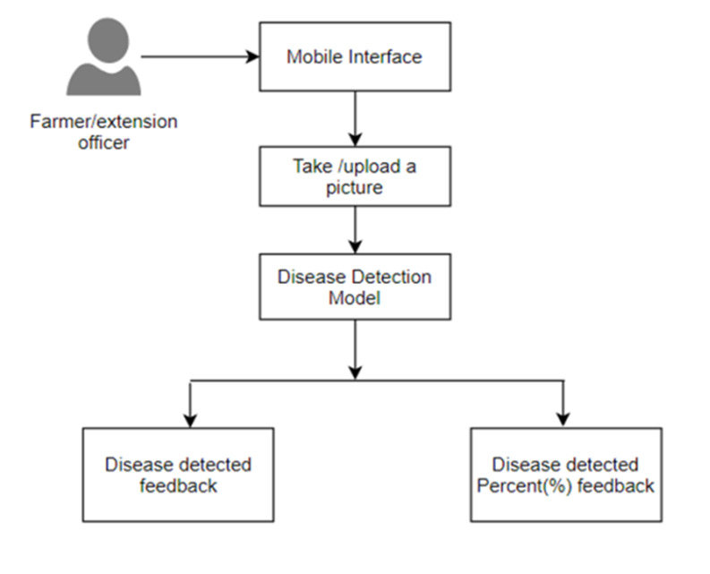DFD Level 1 (Detailed Flow):  
- User uploads poultry image  
- Web Application validates image and sends it to AI Model  
- AI Model processes image and predicts disease  
- Result shown on Web Interface  
- (Optional) Result stored in database for user history

# **User Stories:**

The table below lists the user stories that describe how different users will interact with the system.

|  |  |  |  |  |  |
| --- | --- | --- | --- | --- | --- |
| User Type | Functional Requirement (Epic) | User Story No. | User Story / Task | Acceptance Criteria | Priority / Release |
| Customer (Mobile user) | Registration | USN-1 | As a user, I can register by entering my email, password, and confirm password. | I can access my account / dashboard | High / Sprint-1 |
|  | Registration | USN-2 | As a user, I receive a confirmation email after registering. | I can receive email & click confirm | High / Sprint-1 |
|  | Registration | USN-3 | As a user, I can register using Facebook. | I can access the dashboard with Facebook login | Low / Sprint-2 |
|  | Registration | USN-4 | As a user, I can register using Gmail. | I can access the dashboard with Gmail login | Medium / Sprint-1 |
|  | Login | USN-5 | As a user, I can log in using my email and password. | I am redirected to dashboard after successful login | High / Sprint-1 |

# **4. Technical Architecture:**

|  |  |
| --- | --- |
| Date | 16th June 2025 |
| Team ID | LTVIP2025TMID34447 |
| Project Name | Transfer Learning-Based Classification of Poultry Diseases for Enhanced Health Management |
| Maximum Marks | 4 Marks |

The project uses a simple 3-tier architecture:  
Frontend (User Interface) → Backend (Application Logic + AI Model) → Data Storage  
  
Architecture Flow:  
- User uploads image via browser (HTML/Flask)  
- Image is processed by AI model (VGG16 via TensorFlow)  
- Result is returned to user and optionally stored in database

## **Table-1: Components & Technologies**

|  |  |  |  |
| --- | --- | --- | --- |
| S.No | Component | Description | Technology Used |
| 1 | User Interface | How users interact (via browser) | HTML, CSS, JavaScript, Flask Templates |
| 2 | Application Logic-1 | Web app routing and backend logic | Python, Flask |
| 3 | Application Logic-2 | Image preprocessing for model input | OpenCV, Pillow (PIL) |
| 4 | Application Logic-3 | AI Model Prediction using VGG16 | TensorFlow, Keras |
| 5 | Database | Store user details, history | SQLite / MySQL |
| 6 | Cloud Database | Optional – Cloud-based database storage | Firebase / Google Cloud SQL (optional) |
| 7 | File Storage | Temporary storage of uploaded images | Local File System |
| 8 | External API-1 | Optional – Add weather info (future scope) | OpenWeather API (optional) |
| 9 | External API-2 | Not used | – |
| 10 | Machine Learning Model | Classify poultry disease from images | VGG16 with Transfer Learning |
| 11 | Infrastructure | Hosted on local system or cloud (future scope) | Localhost / Google Cloud / Render / AWS |

## **Table-2: Application Characteristics**

|  |  |  |  |
| --- | --- | --- | --- |
| S.No | Characteristics | Description | Technology Used |
| 1 | Open-Source Frameworks | Used free and open-source libraries | Flask, TensorFlow, OpenCV |
| 2 | Security Implementations | Basic data validation, secure file upload, HTTPS (future scope) | Flask Validation, SHA256 (optional) |
| 3 | Scalable Architecture | Based on modular 3-tier design (frontend, backend, model) | Flask API + ML microservice |
| 4 | Availability | Can be hosted on any cloud with 24/7 uptime using hosting providers | Google Cloud, AWS (optional) |
| 5 | Performance | Light model, low-latency image processing, suitable for real-time use | Model size optimized, Cacheable |

**3. PROJECT DESIGN**

**4.1 Problem – Solution Fit Template**

# **1. CUSTOMER SEGMENT(S) (CS)**

|  |  |
| --- | --- |
| Date | 16th June 2025 |
| Team ID | LTVIP2025TMID34447 |
| Project Name | Transfer Learning-Based Classification of Poultry Diseases for Enhanced Health Management |
| Maximum Marks | 2 Marks |

Rural poultry farmers, small-scale poultry business owners

# **2. JOBS TO BE DONE / PROBLEMS (J&P)**

• Unable to identify poultry diseases early  
• No quick access to veterinary help  
• Loss of birds results in financial loss

# **3. TRIGGERS (TR)**

• Seeing other farmers lose flocks  
• Noticing symptoms like rashes or weakness  
• Fear of disease spread

# **4. PROBLEM ROOT CAUSE (RC)**

• Lack of access to vets  
• No easy tool for disease detection  
• Farmers lack digital knowledge

**5. AVAILABLE SOLUTIONS (AS)**

• Traditional vet clinics (far away)  
• Manual observation (less accurate)  
• Some paid mobile apps (not affordable)

# **6. CUSTOMER CONSTRAINTS (CC)**

• Lack of smartphones/internet  
• Limited income  
• Lack of awareness of tech-based tools

# **7. YOUR SOLUTION (SL)**

• A simple web tool to detect poultry diseases using image upload  
• Uses AI model (VGG16) to predict disease from photo  
• Free, easy-to-use, works on mobile browser

# **8. BEHAVIOUR (BE)**

• Asking neighbors or local shop owners  
• Waiting until it's too late  
• Trial-and-error treatment

# **9. CHANNELS OF BEHAVIOUR (CH)**

• Local vet or nearby farmer  
• WhatsApp groups  
• Occasional search on Google or YouTube

**4.2 Proposed – Solution Fit Template**

|  |  |
| --- | --- |
| Date | 16th June 2025 |
| Team ID | LTVIP2025TMID34447 |
| Project Name | Transfer Learning-Based Classification of Poultry Diseases for Enhanced Health Management |
| Maximum Marks | 2 Marks |

|  |  |  |
| --- | --- | --- |
| S.No. | Parameter | Description |
| 1 | Problem Statement | Many poultry farmers struggle to detect diseases in chickens early due to lack of expertise and access to veterinary help. This leads to bird deaths and financial loss. |
| 2 | Idea / Solution Description | We are building a web-based tool where farmers can upload a chicken image. Our AI model (VGG16 with transfer learning) will analyze the image and predict the disease instantly. |
| 3 | Novelty / Uniqueness | Unlike traditional vet consultations, our solution is instant, remote, and image-based. It uses machine learning trained on poultry images, tailored for rural users. |
| 4 | Social Impact / Customer Satisfaction | This solution can help farmers reduce bird deaths, improve poultry health, and save money. It empowers rural farmers with access to modern technology in a simple way. |
| 5 | Business Model (Revenue Model) | Initially offered for free. Future plans could include paid features like detailed reports, vet consultation, disease trends, or mobile app version. |
| 6 | Scalability of the Solution | The model can be scaled to detect more poultry diseases and adapted for mobile apps. It can also expand to other livestock or crop disease detection. |

**4.3 Solution Architecture**

|  |  |
| --- | --- |
| Date | 16th June 2025 |
| Team ID | LTVIP2025TMID34447 |
| Project Name | Transfer Learning-Based Classification of Poultry Diseases for Enhanced Health Management |
| Maximum Marks | 4 Marks |

**Purpose:**

Solution architecture helps bridge the gap between business problems and technology solutions. Its goals are to:  
• Find the best tech solution to solve existing business problems.  
• Describe the structure, behavior, and characteristics of the system to stakeholders.  
• Define features, development phases, and solution requirements.  
• Provide specifications to ensure the solution is well-defined, managed, and delivered.

**Architecture Overview:**

Our poultry disease detection system uses a 3-tier architecture that includes the frontend, backend logic, and a trained machine learning model for disease prediction. The user uploads an image of a poultry bird, which is processed and predicted using a transfer learning model (VGG16). The result is returned on the interface, and optionally stored.

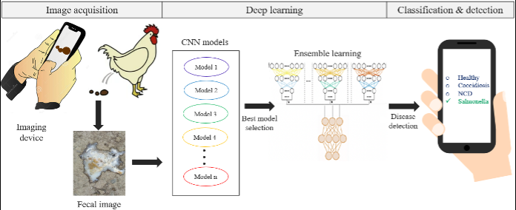

**5. PROJECT PLANNING & SCHEDULING**

|  |  |
| --- | --- |
| Date | 16th June 2025 |
| Team ID | LTVIP2025TMID34447 |
| Project Name | Transfer Learning-Based Classification of Poultry Diseases for Enhanced Health Management |
| Maximum Marks | 5 Marks |

# **Product Backlog, Sprint Schedule, and Estimation (4 Marks)**

|  |  |  |  |  |  |  |  |
| --- | --- | --- | --- | --- | --- | --- | --- |
| Sprint | Functional Requirement (Epic) | User Story Number | User Story / Task | Story Points | Priority | Team Members | Remarks |
| Sprint-1 | Registration | USN-1 | As a user, I can register for the application by entering my email, password, and confirming my password. | 2 | High | All Team Members |  |
| Sprint-1 | Registration | USN-2 | As a user, I will receive confirmation email once I have registered for the application | 1 | High | All Team Members |  |
| Sprint-2 | Registration | USN-3 | As a user, I can register for the application through Facebook | 2 | Low | Hari Chandana, Ashok |  |
| Sprint-1 | Registration | USN-4 | As a user, I can register for the application through Gmail | 2 | Medium | Abhilash, Harshitha |  |
| Sprint-1 | Login | USN-5 | As a user, I can log into the application by entering email & password | 1 | High | Abhilash |  |

# **Project Tracker, Velocity & Burndown Chart (4 Marks)**

## **Sprint Tracking**

|  |  |  |  |  |  |
| --- | --- | --- | --- | --- | --- |
| Sprint | Total Story Points | Duration | Sprint Start Date | Sprint End Date (Planned) | Story Points Completed |
| Sprint-1 | 20 | 3 Days | 14 JUN 2025 | 16 JUN 2025 | 20 |
| Sprint-2 | 20 | 3 Days | 17 JUN 2025 | 19 JUN 2025 | 15 |
| Sprint-3 | 20 | 3 Days | 20 JUN 2025 | 23 JUN 2025 | 18 |
| Sprint-4 | 20 | 4 Days | 24 JUN 2025 | 27 JUN 2025 | 17 |

## **Velocity:**

With a 10-day sprint duration and an average of 20 story points per sprint, the team's velocity is calculated as:  
Velocity = Total Story Points / Duration = 20 / 10 = 2 story points per day.

## **Burndown Chart:**

A burndown chart shows the remaining story points over time in a sprint. It helps track team progress.  
As tasks are completed, the chart drops downward toward zero. The ideal line shows steady progress; deviations help identify delays or blockers.

6. PERFORMANCE TESTING

|  |  |
| --- | --- |
| Date | 16th June 2025 |
| Team ID | LTVIP2025TMID34447 |
| Project Name | Transfer Learning-Based Classification of Poultry Diseases for Enhanced Health Management |
| Maximum Marks |  |

|  |  |  |  |
| --- | --- | --- | --- |
| **S.No.** | **Parameter** | **Values** | **Screenshot** |
|  | Model Summary |  |  |
|  | Accuracy | Training Accuracy - 85.4% Validation Accuracy - 70.1% |  |
| 3. | Fine Tunning Result( if Done) | Validation Accuracy - 72.6% | __ |

**7. RESULT**

Output

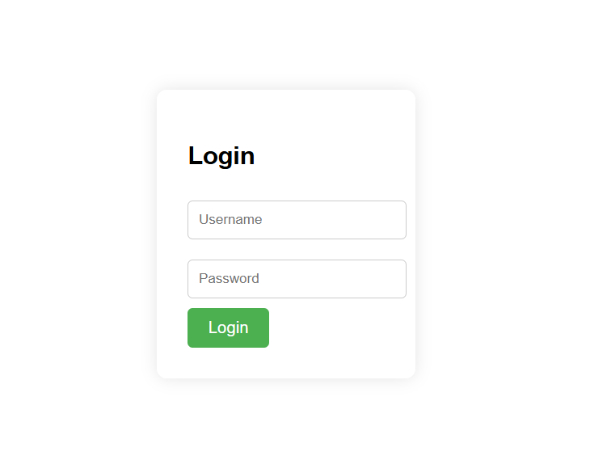

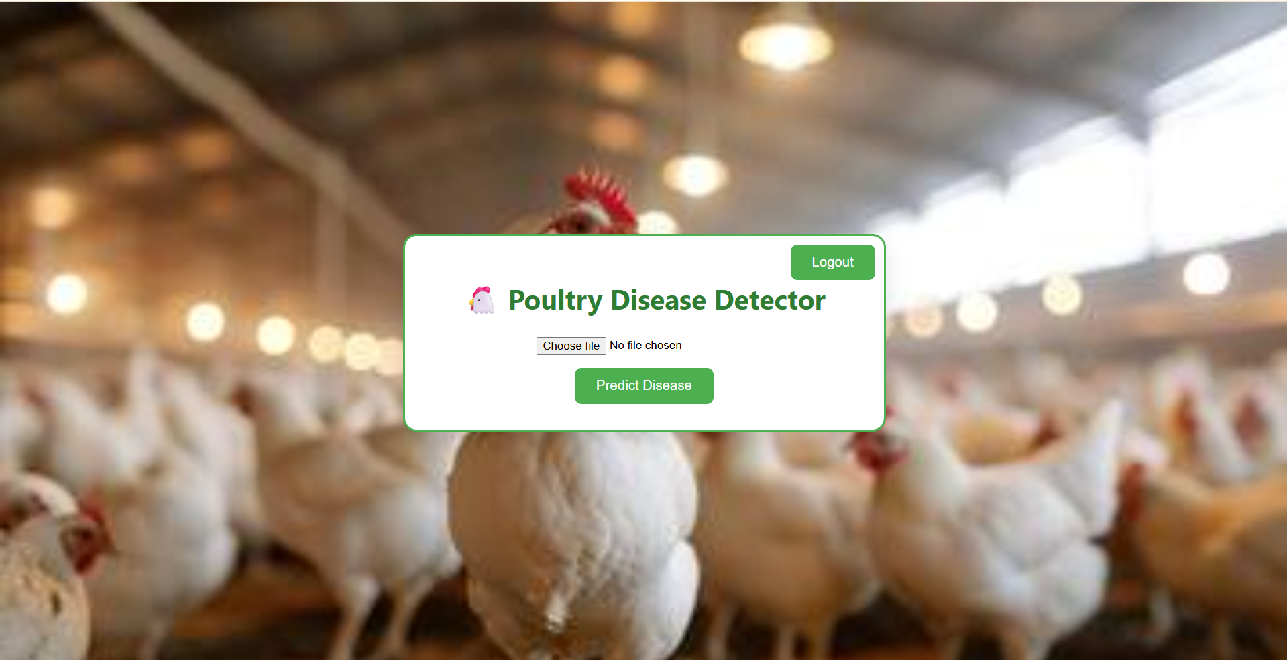

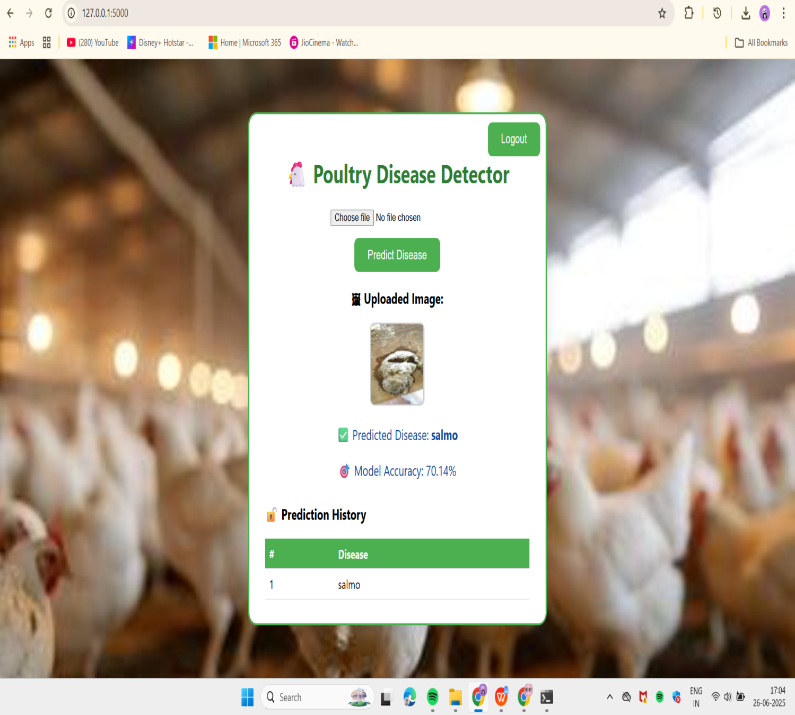

**8. Advantages & Disadvantages**

**Advantages:**

1. Early Detection of Diseases  
     Helps farmers identify poultry diseases quickly before they spread, saving time and birds.
2. Easy to Use  
     The web interface is simple and user-friendly. Farmers only need to upload a photo.
3. Cost-Effective  
     No need for expensive veterinary visits. It can be used from home using a mobile phone.
4. Accessible in Rural Areas  
     Designed to help farmers in remote areas who may not have access to veterinary services.
5. Fast Results  
     The AI model gives disease predictions in just a few seconds.
6. Scalable  
     Can be expanded to detect more poultry diseases or adapted for other animals and crops in the future.
7. Technology Integration  
     Uses modern AI techniques like Transfer Learning (VGG16) for better accuracy with limited data.

**Disadvantages:**

1. Limited Accuracy  
     The current validation accuracy is around 70–72%. It may misclassify in some cases, especially if image quality is poor.
2. Requires Good Internet  
     Users need an internet connection to use the web-based platform, which may not be available in some rural areas.
3. Limited Dataset  
     The model’s accuracy depends on the training data. If the dataset is small or unbalanced, prediction quality can suffer.
4. Not a Complete Replacement for Vets  
     The tool helps in initial detection, but serious or complex cases still require expert medical help.
5. Dependency on Image Quality  
     The tool may not work well if the uploaded images are blurry, unclear, or poorly lit.

**9. Conclusion**

Our project, “Poultry Disease Detection Using Transfer Learning,” provides an AI-based solution to help farmers detect poultry diseases at an early stage using image classification. With the help of the VGG16 model and a simple web interface, users can upload a photo of an infected chicken and get quick predictions about the possible disease.

This tool is especially useful for rural farmers who have limited access to veterinary help. It reduces bird mortality, saves money, and helps in better poultry health management. The system is fast, easy to use, and scalable for future improvements. While the current model shows good performance, we aim to improve accuracy further by using more diverse datasets and advanced models.

In summary, this project is a step toward smarter agriculture using AI — helping farmers stay informed and take faster action to protect their poultry.

**10.  FUTURE SCOPE**

Our project lays the foundation for smart poultry disease detection using AI. In the future, it can be improved and expanded in many useful ways:

🔹 **1. Expand Disease Coverage**  
 Currently, the model detects only a few diseases. We can train it to detect more poultry diseases by using more image data.

🔹 **2. Mobile Application Development**  
 We can create a mobile app so that farmers can easily use the tool on their smartphones.

🔹 **3. Multilingual Interface**  
 The tool can support local languages like Telugu, Hindi, etc., making it easy for rural farmers to understand and use.

🔹 **4. Offline Functionality**  
 A version that works without the internet can be developed for farmers in remote villages.

🔹 **5. Veterinary Consultation Feature**  
 A chat or video call feature can be added to connect farmers with veterinary doctors for expert advice.

🔹 **6. Improved Model Accuracy**  
 By using more images and better AI models like ResNet or EfficientNet, we can improve prediction accuracy.

🔹 **7. Integration with Government Services**  
 The tool can be connected to government animal health services and schemes to help more farmers.

🔹 **8. Use for Other Animals or Crops**  
 The same idea can be used to detect diseases in cows, goats, or even plants using leaf images.

APPENDIX

Soure Code (if any)

**Dataset Link** : <https://www.kaggle.com/datasets/chandrashekarnatesh/poultry-diseases>

**GitHub** : <https://github.com/DASIHARSHITHA/Poultry-Disease-Detection.git>

**Project Demo Link :** [**https://drive.google.com/file/d/1Zgx9jTFvII7GF7ps17TrmDadXsl0TYo/view?usp=drive_link**](https://drive.google.com/file/d/1Zgx9j-TFvII7GF7ps17TrmDadXsl0TYo/view?usp=drive_link)